**EXPERIMENT NO. 01**

**CO/LO: CO1-Develop web applications.**

**AIM / OBJECTIVE:** Design a website including basic html tags, list, image, links, table and forms using only HTML and style the elements of HTML website using CSS.

**THEORY**:

**HTML**

HTML stands for HyperText Markup Language. It is used to design web pages using a markup language. HTML is the combination of Hypertext and Markup language. Hypertext defines the link between web pages. A markup language is used to define the text document within the tag which defines the structure of web pages. This language is used to annotate (make notes for the computer) text so that a machine can understand it and manipulate text accordingly. Most markup languages (e.g. HTML) are human-readable. The language uses tags to define what manipulation has to be done on the text.

**<!DOCTYPE html>:** This is the document type declaration (not technically a tag). It declares a document as being an HTML document. The doctype declaration is not case-sensitive.

**<html>:** This is called the HTML root element. All other elements are contained within it.

**<head>:** The head tag contains the “behind the scenes” elements for a webpage. Elements within the head aren’t visible on the front-end of a webpage.

**HTML elements used inside the <head> element include:**

* <style>-This html tag allows us to insert styling into our webpages and make them appealing to look at with the help of CSS.
* <title>-The title is what is displayed on the top of your browser when you visit a website and contains title of the webpage that you are viewing.
* <base>-It specifies the base URL for all relative URL’s in a document.
* <noscript>– Defines a section of HTML that is inserted when the scripting has been turned off in the users browser.
* <script>-This tag is used to add functionality in the website with the help of JavaScript.
* <meta>-This tag encloses the meta data of the website that must be loaded every time the website is visited. For eg:- the metadata charset allows you to use the standard UTF-8 encoding in your website. This in turn allows the users to view your webpage in the language of their choice. It is a self closing tag.
* <link>– The ‘link’ tag is used to tie together HTML, CSS and JavaScript. It is self closing.

**<body>:** The body tag is used to enclose all the visible content of a webpage. In other words, the body content is what the browser will show on the front-end.

An HTML document can be created using any text editor. Save the text file using **.html** or **.htm**. Once saved as an HTML document, the file can be opened as a webpage in the browser.

**CSS**

**C**ascading **S**tyle **S**heets, fondly referred to as **CSS**, is a simply designed language intended to simplify the process of making web pages presentable. CSS allows you to apply styles to web pages. More importantly, CSS enables you to do this independent of the HTML that makes up each web page. It describes how a webpage should look: it prescribes colors, fonts, spacing, and much more. In short, you can make your website look however you want. CSS lets developers and designers define how it behaves, including how elements are positioned in the browser.

While html uses tags, css uses rulesets. CSS is easy to learn and understand, but it provides powerful control over the presentation of an HTML document.

* **CSS saves time:** You can write CSS once and reuse the same sheet in multiple HTML pages.
* **Easy Maintenance:** To make a global change simply change the style, and all elements in all the webpages will be updated automatically.
* **Search Engines:** CSS is considered a clean coding technique, which means search engines won’t have to struggle to “read” its content.
* **Superior styles to HTML:** CSS has a much wider array of attributes than HTML, so you can give a far better look to your HTML page in comparison to HTML attributes.
* **Offline Browsing:** CSS can store web applications locally with the help of an offline cache. Using this we can view offline websites.

**EXAMPLE**: Create a webpage as shown below using HTML and CSS

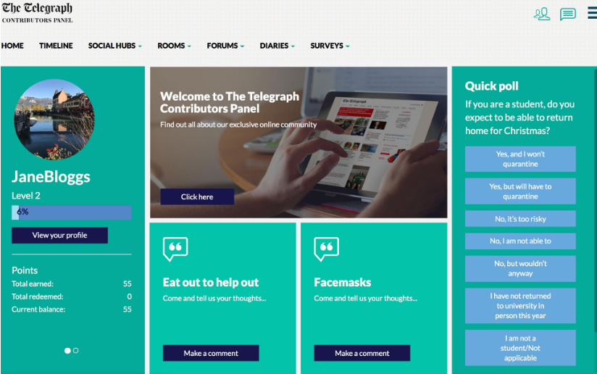

**PRACTICE QUESTIONS:**

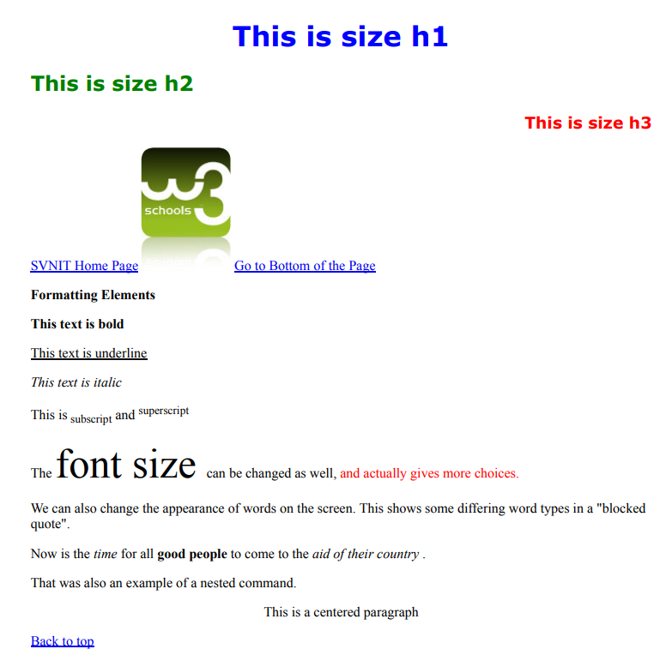

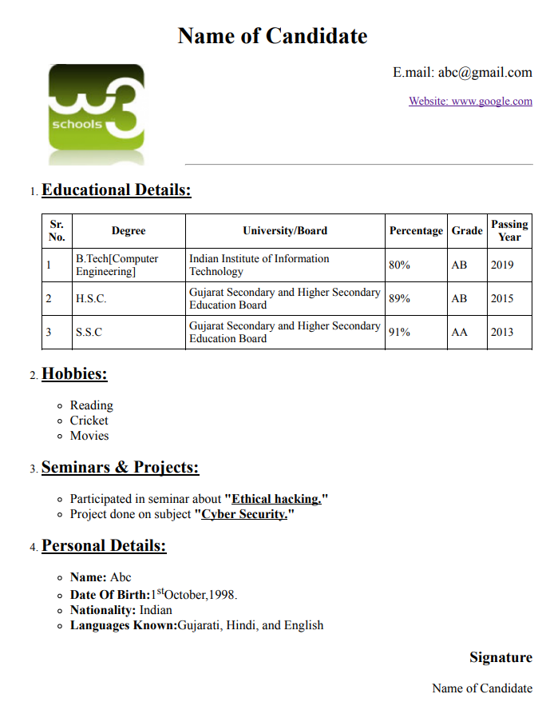

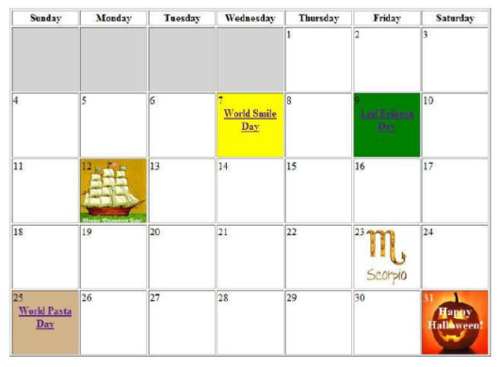

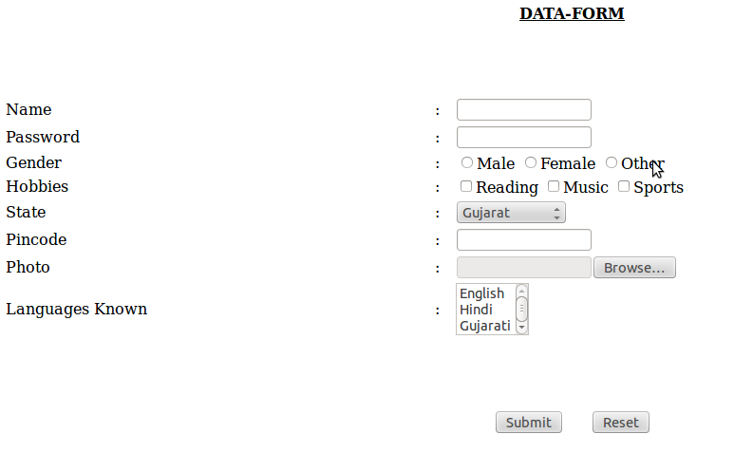

**BOOKS AND WEB RESOURCES:**

1. HTML Tutorial Online Available: <https://www.tutorialspoint.com/html/index.htm>
2. HTML Introduction Online Available:[https://](https://www.tutorialspoint.com/html/index.htm)www.geeksforgeeks.org/html-introduction/
3. CSS Tutorial Online Available: <https://www.tutorialspoint.com/css/index.htm>
4. CSS Introduction Online Available:https:// [www.geeksforgeeks.org/css-introduction/](http://www.geeksforgeeks.org/css-introduction/)
5. Benjamin LaGrone, “HTML5 and CSS3 Responsive Web Design Cookbook”, 1st Edition, Packt Publishing, 2013.
6. DT Editorial Services, “Web Technologies: Black Book”, 1st Edition, Dreamtech Press, 2018.
7. Christopher Schmitt, Kyle Simpson, “HTML5 Cookbook”, 1st Edition, O'Reilly Media Inc., 2011